*FINAL PROJECT REPORT*

***PROJECT TITLE***

MEDICAL INVENTORY MANAGEMENT

COLLEGE NAME

ANNAMACHARYA INSTITUTE OF

TECHNOLOGY AND SCIENCES, TIRUPATI

***TEAM MEMBERS***

***:Vadla VenuPriya (Team Leader)***

***-priyaroyalvadla@gmail.com***

* + - * + ***Madala srihitha (Team Member)***

***-srihithamadala@gmail.com***

***Kuntrapaku yuvasree(Team Member)***

* ***Yuvasree1320@gmail.com***
  + - * + ***Aadepudi Keerthi (Team Member)***

-keerthiadepudi@gmail.com

***1.INTRODUCTION***

***1.1 Project Overview***:

The Medical Inventory Management project aims to develop a comprehensive inventory management system for healthcare organizations using Salesforce. The system will enable real-time tracking of medical supplies, equipment, and pharmaceuticals, ensuring that healthcare professionals have access to the resources they need to provide high-quality patient care.

This project is a comprehensive Salesforce application to streamline and manage various operational aspects of medical inventory. The system aims to efficiently maintain supplier details, manage purchase orders, track product details and transactions, and monitor the expiry dates of products. Maintain detailed records of suppliers, including contact information. Catalog product information, including descriptions, stock levels. Monitor and track product expiry dates to avoid using expired items. Comprehensive reports to track supplier performance, and purchase orders.

The Medical Inventory Management project aims to develop a comprehensive Salesforce-based solution for managing medical inventory in healthcare organizations. The system will enable healthcare professionals to track inventory levels in real-time, automate reordering processes, and gain visibility into inventory movement. This will help reduce stockouts, overstocking, and manual errors, ultimately improving patient care and operational efficiency.

By developing a Medical Inventory Management system in Salesforce, healthcare organizations can improve patient care,reduce costs, and increase efficiency, ultimately leading to better healthcare outcomes.

***1.2 Purpose:***

The purpose of this project is to streamline medical inventory management processes, reducing stockouts, overstocking, and manual errors, while improving patient care and operational efficiency.

* Solve complex problems in a way that fits the state of your customers.
* Succeed faster and increase your solution adoption by tapping into existing mediums and channels of behavior.
* Sharpen your communication and marketing strategy with the right triggers and messaging.
* Increase touch-points with your company by finding the right problem-behavior fit and building trust by solving frequent annoyances, or urgent or costly problems.

1. Streamline inventory management: Automate and optimize inventory management processes for medical supplies, equipment, and pharmaceuticals.

2. Improve visibility and tracking: Provide real-time visibility into inventory levels, locations, and movement.

3. Enhance patient care: Ensure that medical supplies and equipment are available when needed, improving patient care and outcomes.

4. Reduce costs: Optimize inventory levels, reducing waste and costs associated with overstocking or understocking.

5. Increase efficiency: Automate inventory management workflows, reducing manual errors and increasing productivity.

***2.IDEATION PHASE***

***2.1 Problem Statement:***

Healthcare organizations face challenges in managing medical inventory, including stockouts, overstocking, and manual errors, leading to wasted resources, delayed patient care, and increased costs***.***

The problem statement highlights the need for a comprehensive solution that can address these challenges and improve medical inventory management.

Create a problem statement to understand your customer's point of view. The Customer Problem Statement template helps you focus on what matters to create experiences people will love.

A well-articulated customer problem statement allows you and your team to find the ideal solution for the challenges your customers face. Throughout the process, you’ll also be able to empathize with your customers, which helps you better understand how they perceive your product or service.

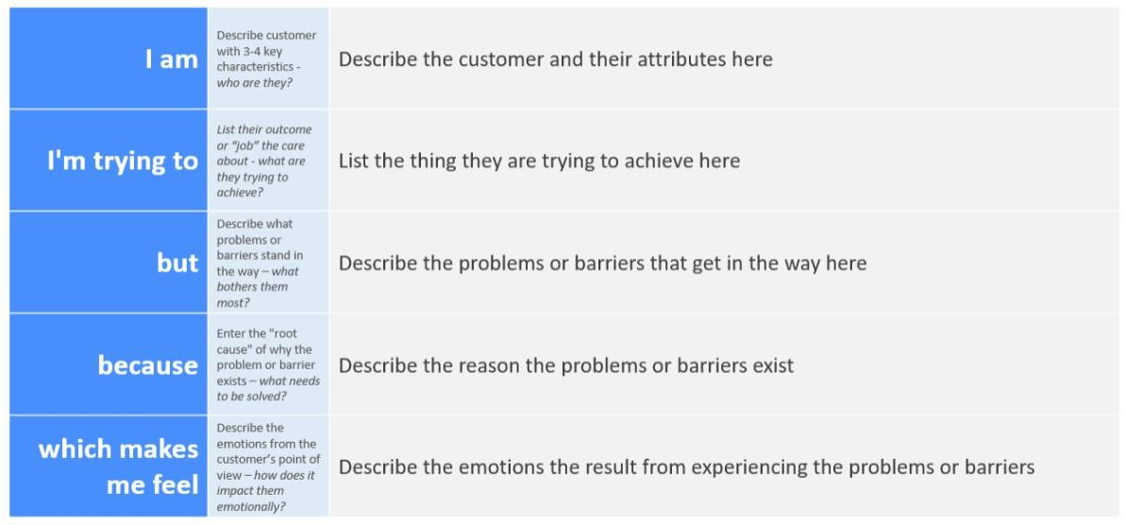

***2.2 Empathy Map Canvas:***

The empathy map canvas is a tool used to identify the needs, pain points, and behaviors of healthcare professionals involved in inventory management. By understanding the perspectives of these professionals, the project team can design a solution that meets their needs and addresses their pain points.

The empathy map canvas will help identify the needs, pain points, and behaviors of healthcare professionals involved in inventory management.

An empathy map is a simple, easy-to-digest visual that captures knowledge about a user’s behaviours and attitudes. It is a useful tool to helps teams better understand their users.

Creating an effective solution requires understanding the true problem and the person who is experiencing it. The exercise of creating the map helps participants consider things from the user’s perspective along with his or her goals and challenges.

***EXAMPLE:***

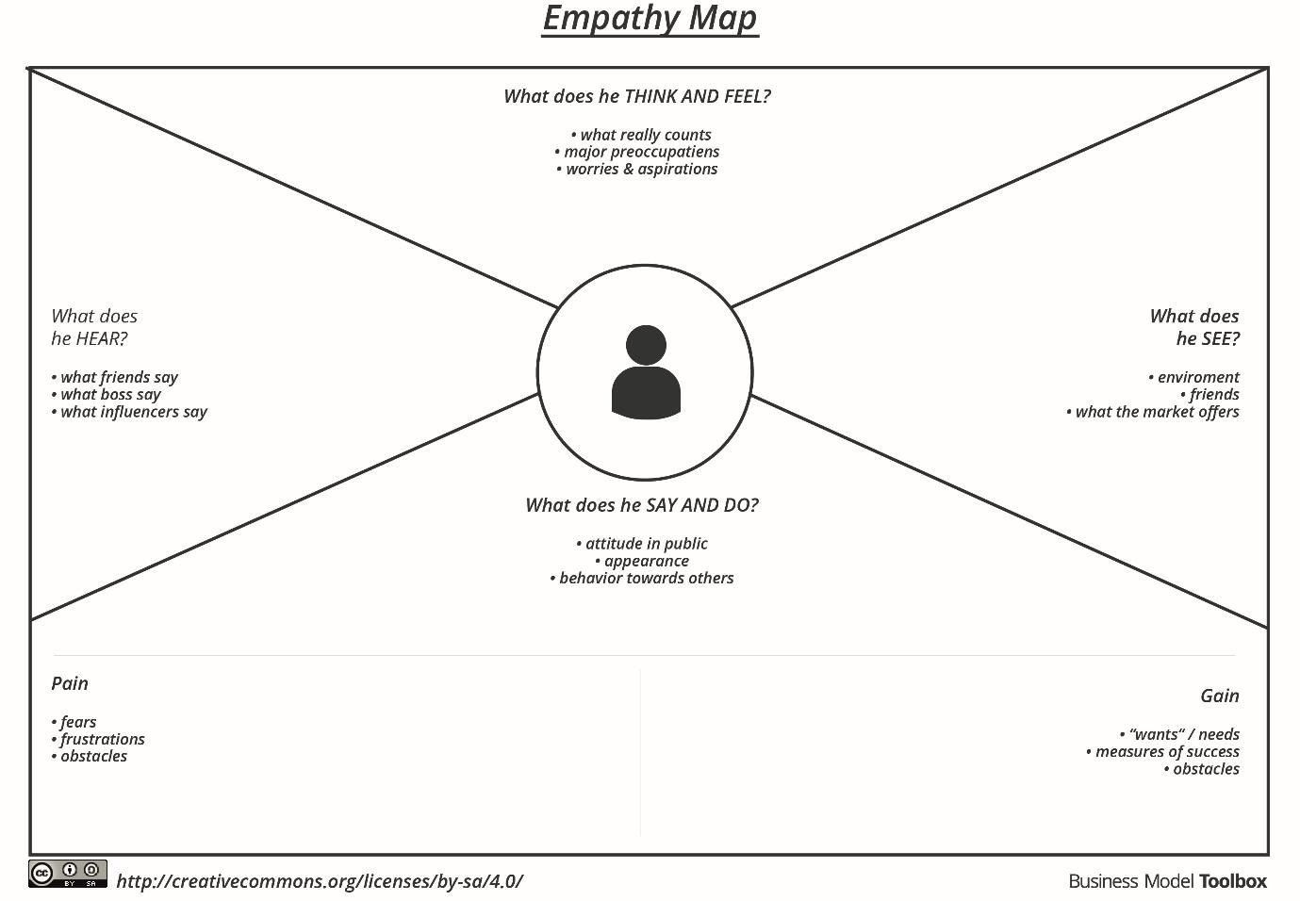

***MEDICAL INVENTORY MANAGEMENT***

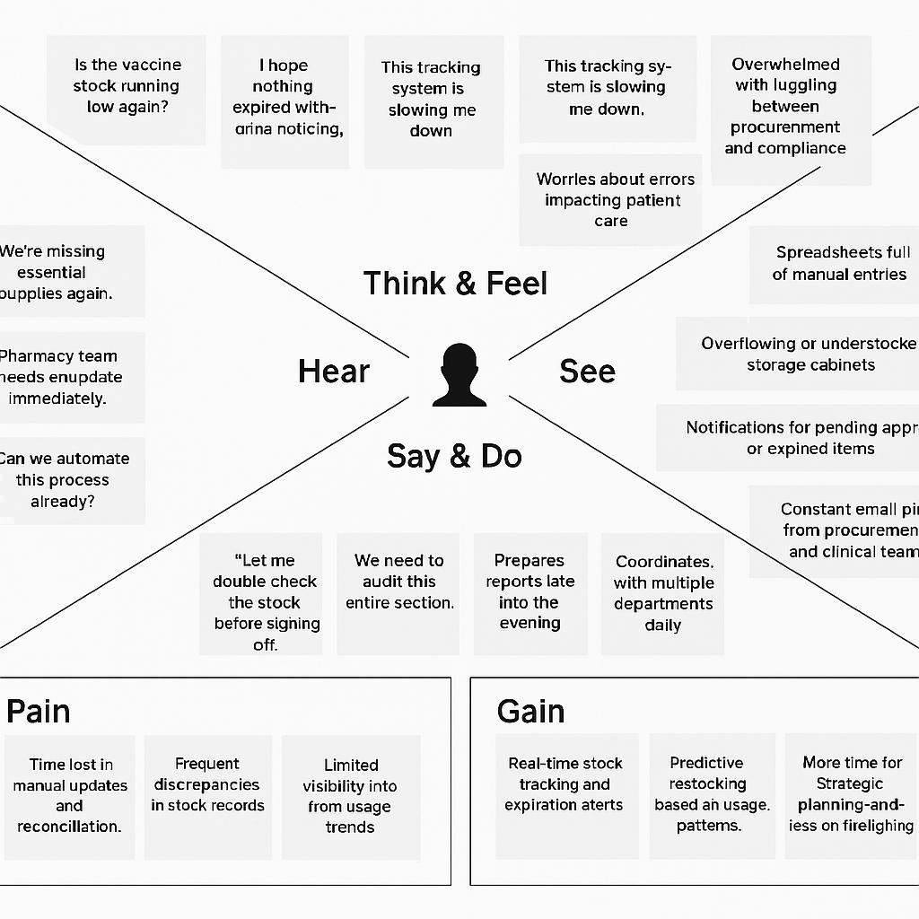

***2.3 Brainstorming:***

Brainstorming provides a free and open environment that encourages everyone within a team to participate in the creative thinking process that leads to problem solving. Prioritizing volume over value, out-of-the-box ideas are welcome and built upon, and all participants are encouraged to collaborate, helping each other develop a rich amount of creative solutions.

Brainstorming sessions will generate ideas for improving medical inventory management, such as :

- Automating inventory tracking

- Implementing RFID technology

- Integrating with supplier systems for seamless inventory management

- Providing real-time visibility into inventory movement

Step-1: Team Gathering, Collaboration and Select the Problem Statement

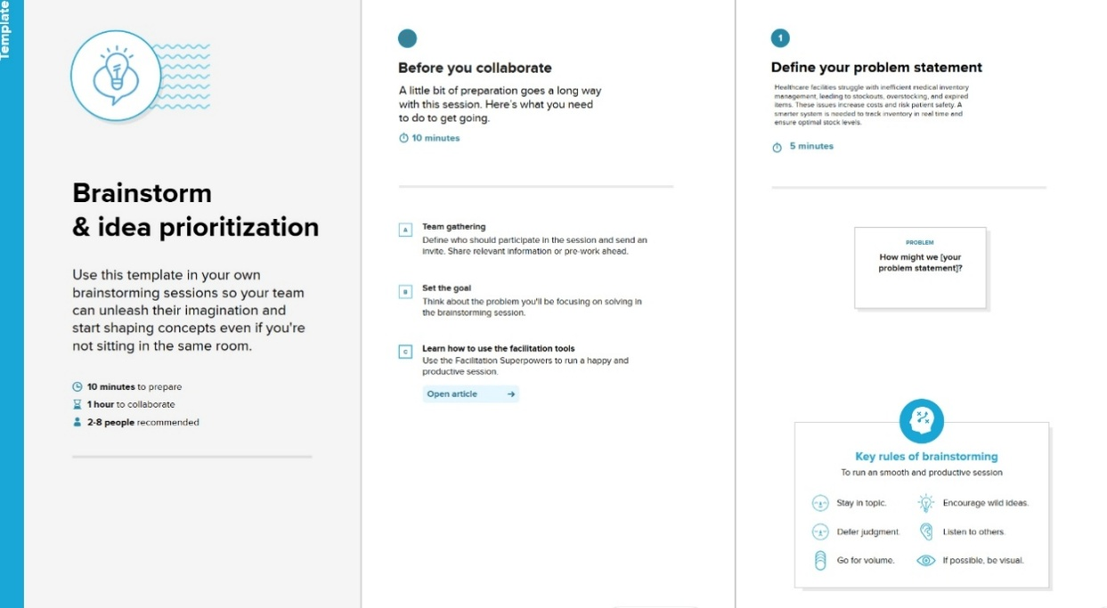

Step-2: Brainstorm, Idea Listing and Grouping

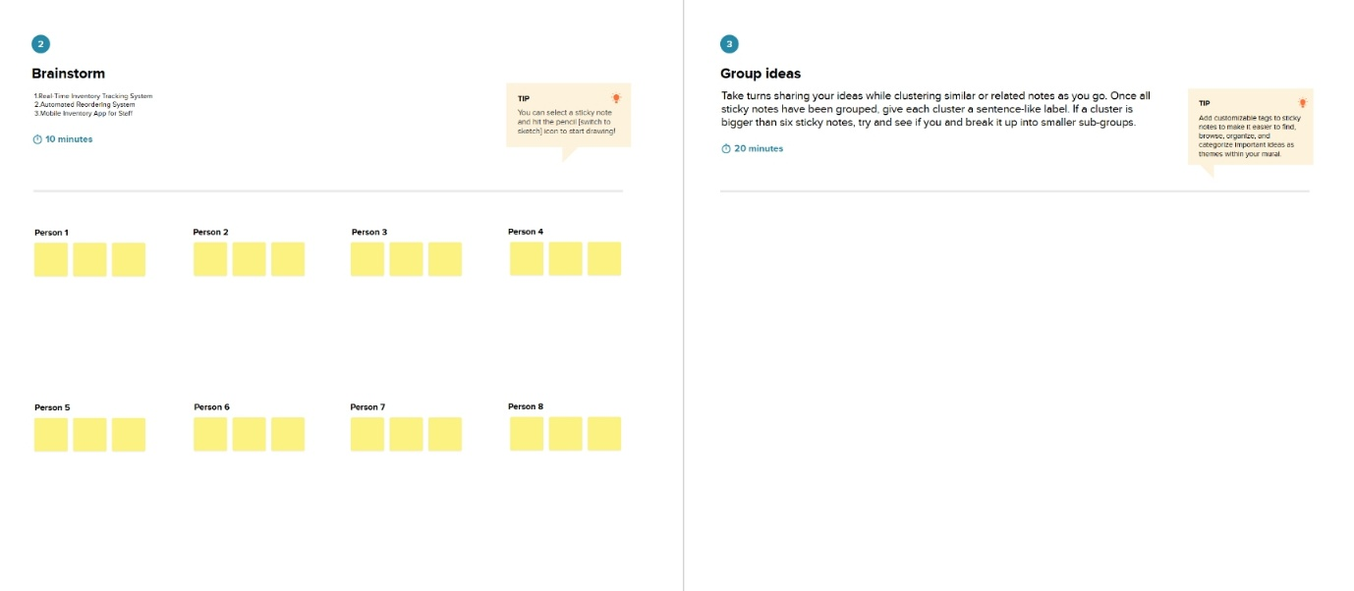

**Step-3: Idea Prioritization**

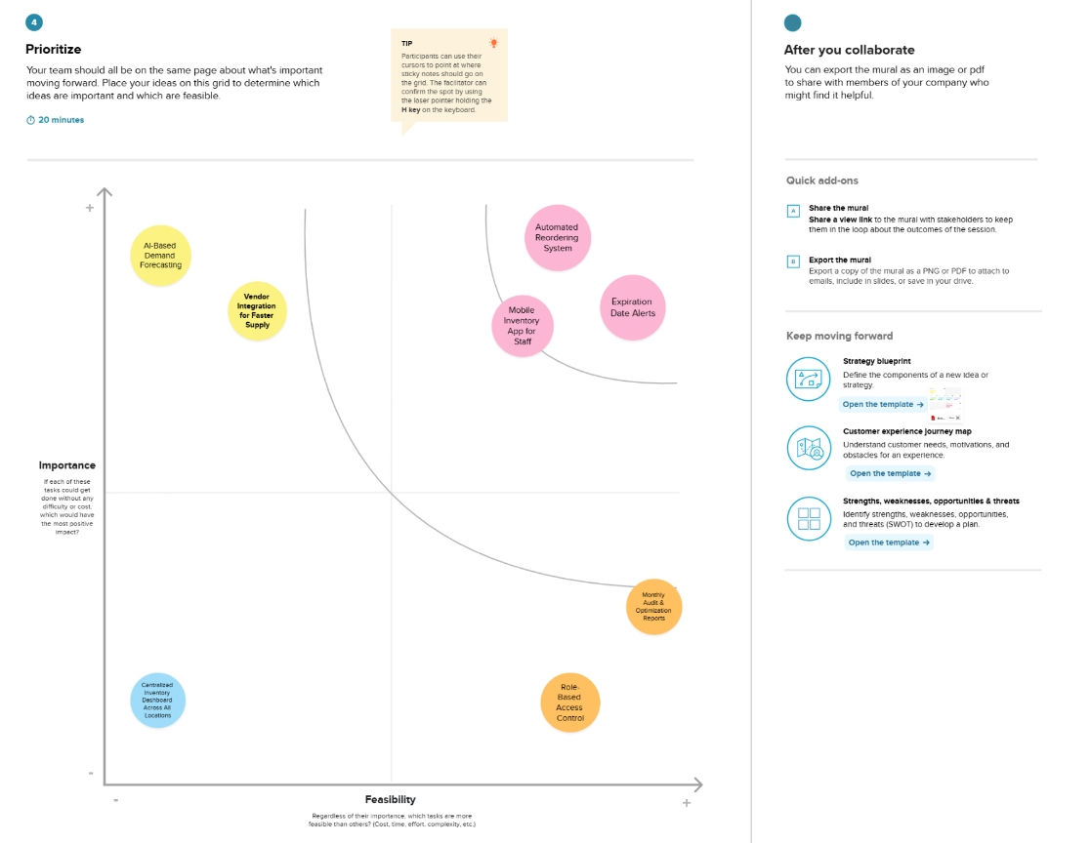

***3.REQUIREMENT ANALYSIS***

***3.1 Customer Journey Map***

The customer journey map will illustrate the steps involved in managing medical inventory, highlighting pain points and areas for improvement.

This will help the project team design a solution that addresses the specific needs of healthcare professionals.

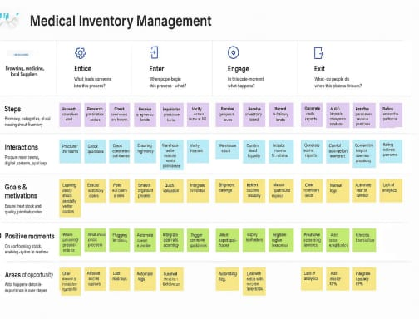

***3.2 Solution Requirement***

The solution requirements will include features such as

* + - Inventory tracking Management
    - Automated reordering Processes
    - Real-time visibility into inventory movement
    - Integration with supplier systems.
    - Reporting and analytics
* **Functional Requirements:**
* Following are the functional requirements of the proposed solution.

|  |  |  |
| --- | --- | --- |
| **FR No.** | **Functional Requirement (Epic)** | **Sub Requirement (Story / Sub-Task)** |
| FR-1 | User Registration | Registration through Form  Registration through Gmail  Registration through LinkedIN |
| FR-2 | User Confirmation | Confirmation via Email  Confirmation via OTP |
| FR-3 | Login | Login with Email and Password  Login with Social Accounts(Gmail,LinkedIn)  Forgot Password/Password Reset |
| FR-4 | Dashboard | View Inventory Summary  View Notifications (Low stock, Expiry alerts)  Quick Access to Recent Orders / Shipments |
| FR-5 | |  | | --- | | Inventory Management |  |  | | --- | |  | | Add New Medical Stock  Edit or Delete Existing Stock  View Medicine Details  Filter/Search by Category or Medicine Name |
| FR-6 | Stock Alerts | Auto-alerts for Low Stock  Auto-alerts for Expiring Medicines |

**Non-functional Requirements:**

Following are the non-functional requirements of the proposed solution.

|  |  |  |
| --- | --- | --- |
| **FR No.** | **Non-Functional Requirement** | **Description** |
| NFR-1 | **Usability** | The system should be easy to use and understand for all users. |
| NFR-2 | **Security** | The system should keep all data safe and allow access only to the right people. |
| NFR-3 | **Reliability** | The system should work properly all the time without losing any data. |
| NFR-4 | **Performance** | The system should respond quickly when users search, add, or update stock. |
| NFR-5 | **Availability** | The system should be available all the time, with very little downtime |
| NFR-6 | **Scalability** | The system should be able to handle more users and stock as the business grows. |

***3.3 Data Flow Diagram***

The data flow diagram will illustrate the flow of data between different components of the system, including inventory tracking, ordering, and supplier integration.

This will help the project team design a solution that is efficient, scalable, and effective.

A Data Flow Diagram (DFD) is a traditional visual representation of the information flows within a system. A neat and clear DFD can depict the right amount of the system requirement graphically. It shows how data enters and leaves the system, what changes the information, and where data is stored.

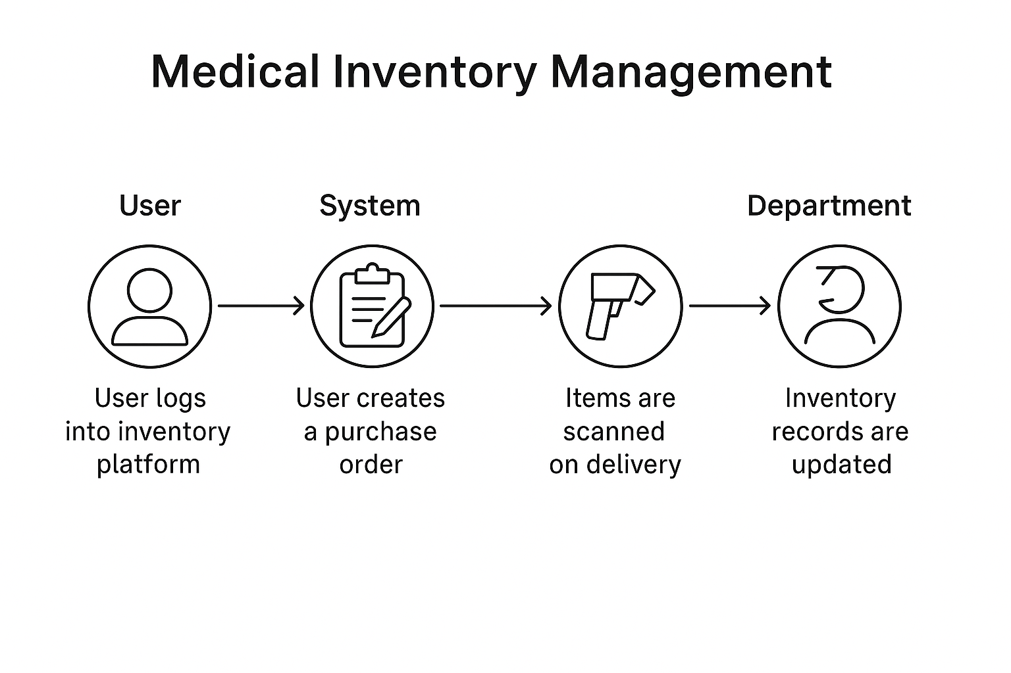

***3.4 Technology Stack***

The technology stack will include:

* + Salesforce: A cloud-based platform for building custom applications
  + Apex: A programming language used for developing custom logic on the Salesforce platform
  + Lightning: A framework for building custom user interfaces on the Salesforce platform
  + RFID or barcode scanning: Technologies used for automating inventory tracking

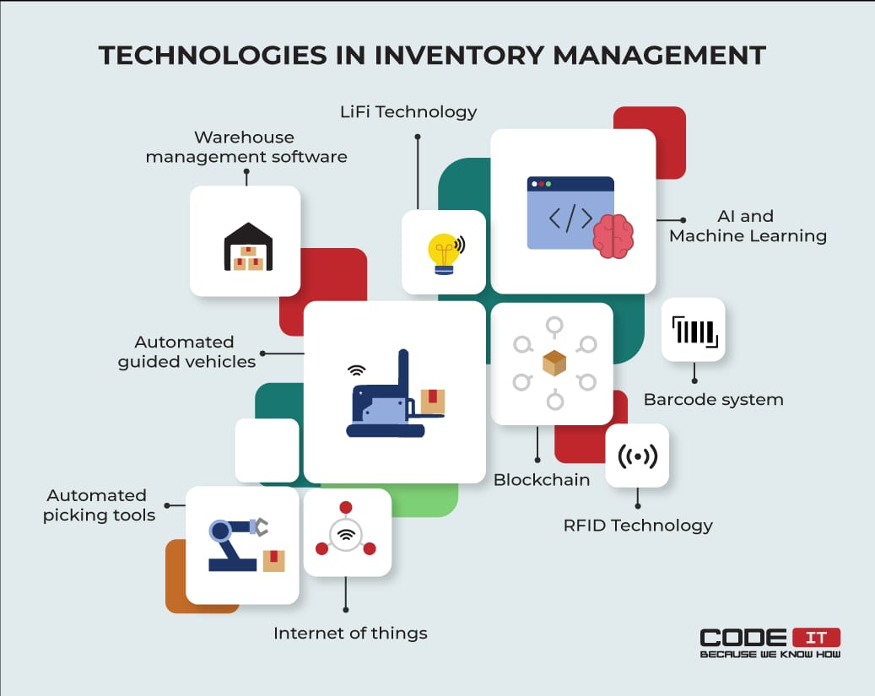

***4.PROJECT DESIGN***

***4.1 Problem Solution fit***

The proposed solution will address the challenges of medical inventory management by providing real-time visibility, automating inventory tracking, and streamlining ordering processes.

The Problem-Solution Fit simply means that you have found a problem with your customer and that the solution you have realized for it actually solves the customer’s problem. It helps entrepreneurs, marketers and corporate innovators identify behavioral patterns and recognize what would work and why

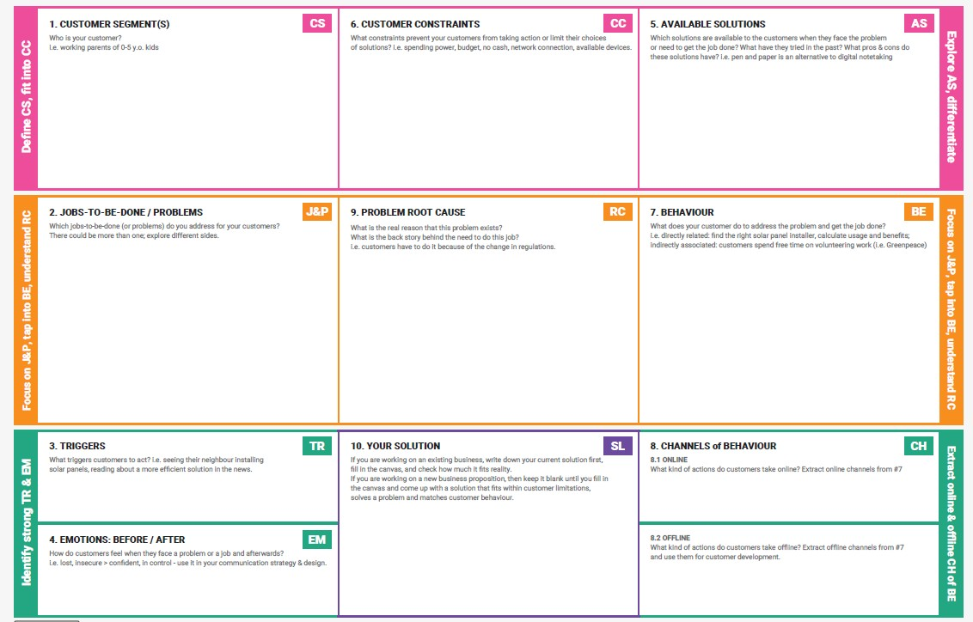

***4.2 Proposed Solution***

The proposed solution will include features such as inventory tracking, automated reordering, and real-time visibility, leveraging Salesforce's capabilities.

|  |  |  |
| --- | --- | --- |
| **S.No.** | **Parameter** | **Description** |
| 1. | Problem Statement (Problem to be solved) | Inefficient tracking, stockouts, overstocking, and wastage of critical medical supplies in healthcare facilities due to lack of real-time visibility and automation in inventory management |
| 2. | Idea / Solution description | Develop a cloud-based Medical Inventory Management System using  Salesforce to automate stock tracking, generate alerts for low/expired stock, streamline reordering, and provide real-time inventory insights. |
| 3. | Novelty /  Uniqueness | Uses Salesforce’s low-code/no-code capabilities and Health Cloud integration for a healthcare-specific inventory solution. Incorporates intelligent reordering logic and compliance tracking for medical use. |
| 4. | Social Impact /  Customer  Satisfaction | Ensures critical medical supplies are always available, directly impacting patient care quality. Reduces waste, improves operational efficiency, and increases satisfaction for both patients and medical staff. |
| 5. | Business Model (Revenue Model) | SaaS model: Monthly or annual subscription fees charged to hospitals, clinics, and pharmacies. Optional customization, training,  and support packages available as premium services |
| 6. | Scalability of the Solution | Easily scalable across different sizes of healthcare facilities. Built on Salesforce’s cloud platform, allowing integration with other systems and expansion to multiple locations or regions effortlessly. |

***4.3 Solution Architecture***

The solution architecture will include components

such as:

* Inventory tracking: A module for tracking inventory levels and movement
* Ordering: A module for automating reordering processes
* Supplier integration: A module for integrating with supplier systems
* Reporting and analytics: A module for providing insights into inventory management

The solution architecture will be designed to be efficient, scalable, and effective, leveraging the capabilities of the Salesforce platform.

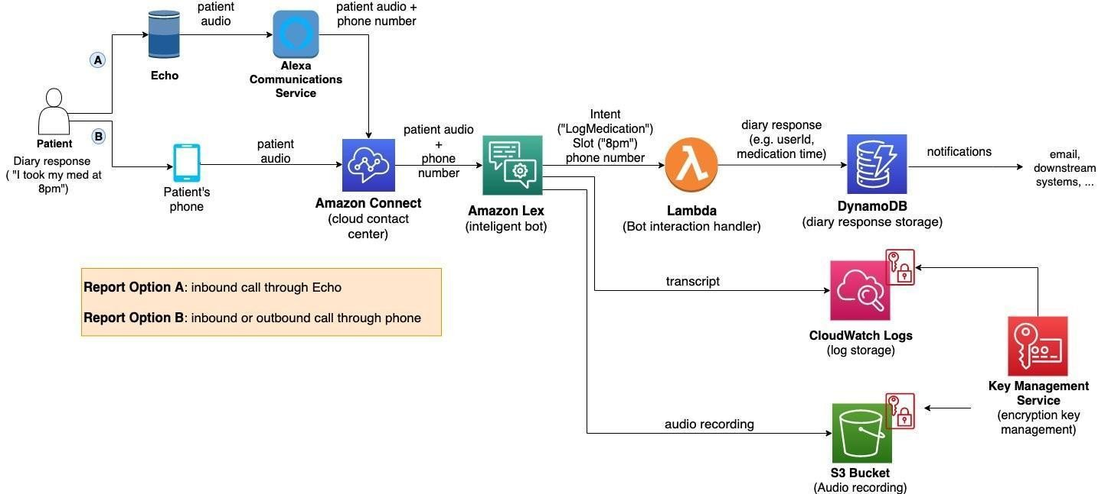

***5.PROJECT PLANNING***

***&***

***SCHEDULING***

***5.1 Project planning***

The project plan will outline the scope, timeline, and resources required for the project, including development, testing, and deployment.

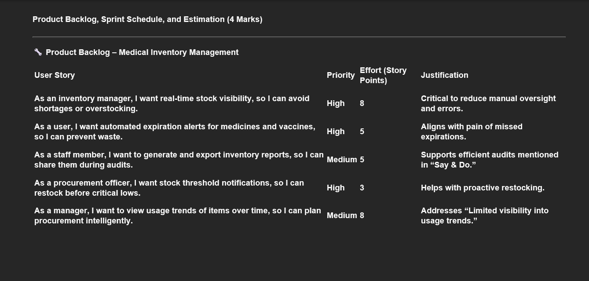

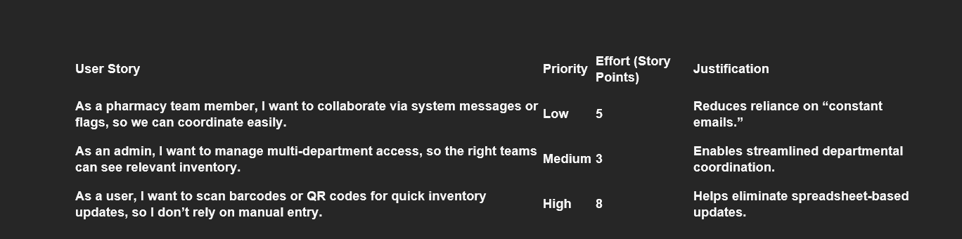

***6.FUNCTIONAL***

***AND***

***PERFORMANCE TESTING***

***6.1 Performance Testing***

Performance testing will ensure the system can handle expected loads and user traffic, providing a seamless user experience

Project team shall fill the following information in model performance testing template.

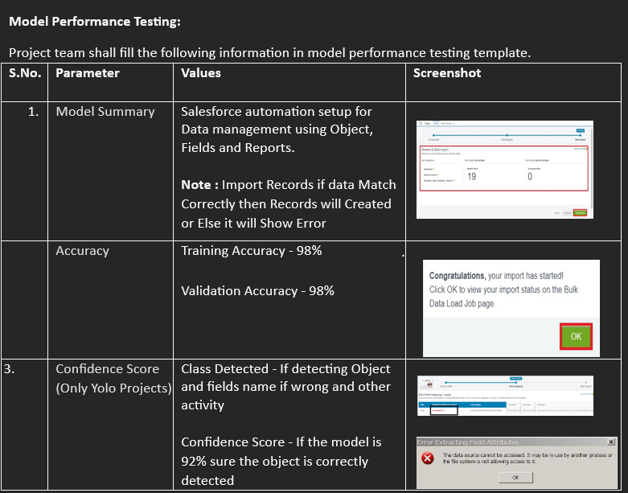

***7.RESULTS***

***7.1 Output Screenshots***

***MILESTONE 1: CREATION OF DEVELOPER ACCOUNT***

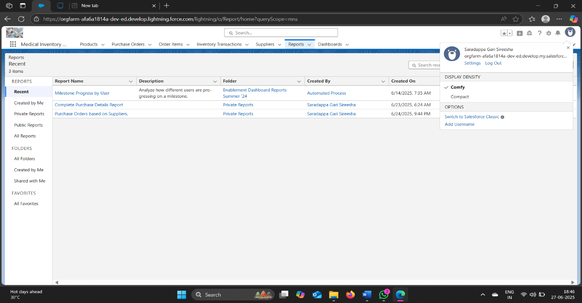



***MILESTONE 2: OBJECT CREATION***

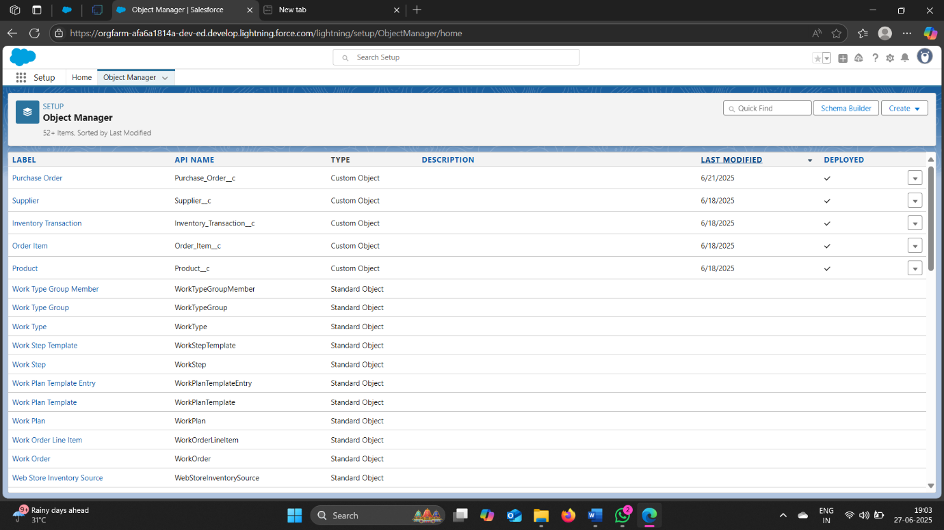

***MILESTONE 3: TABS***

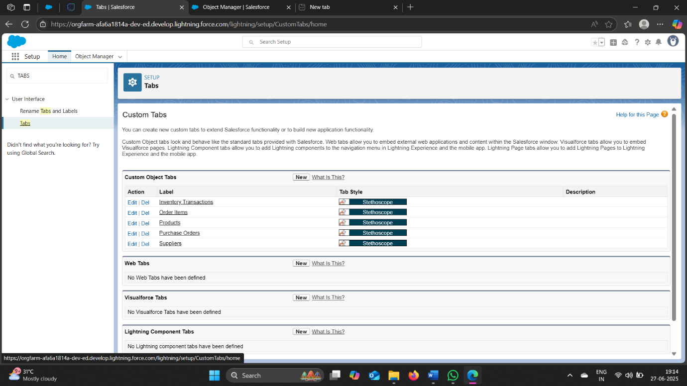

***MILESTONE 4: The Lightning App***

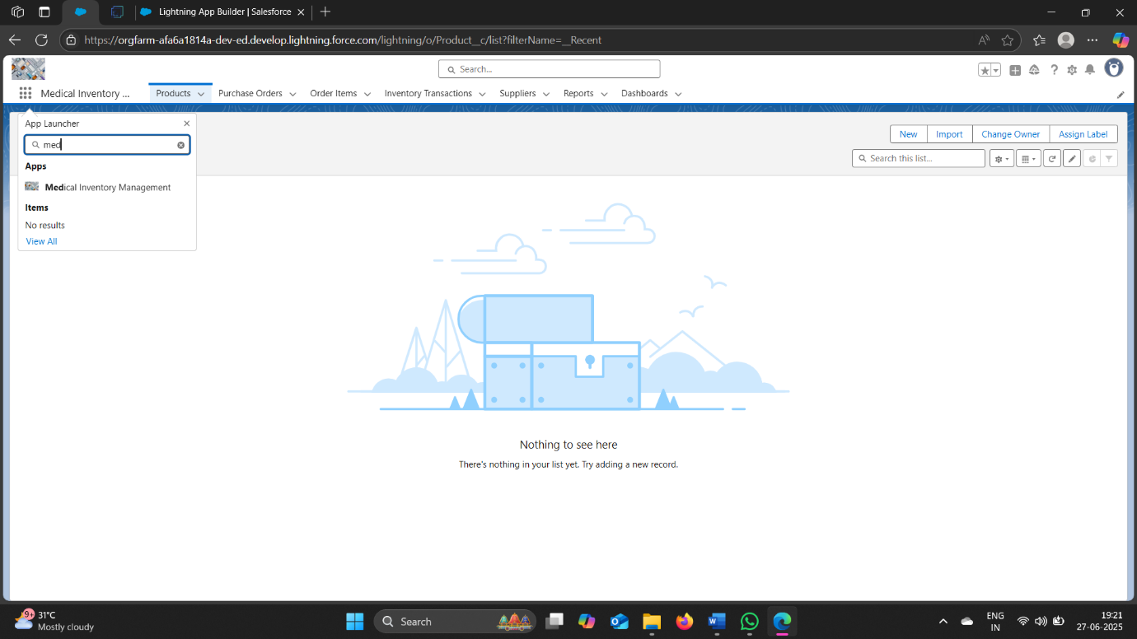

***MILESTONE 5: Fields***

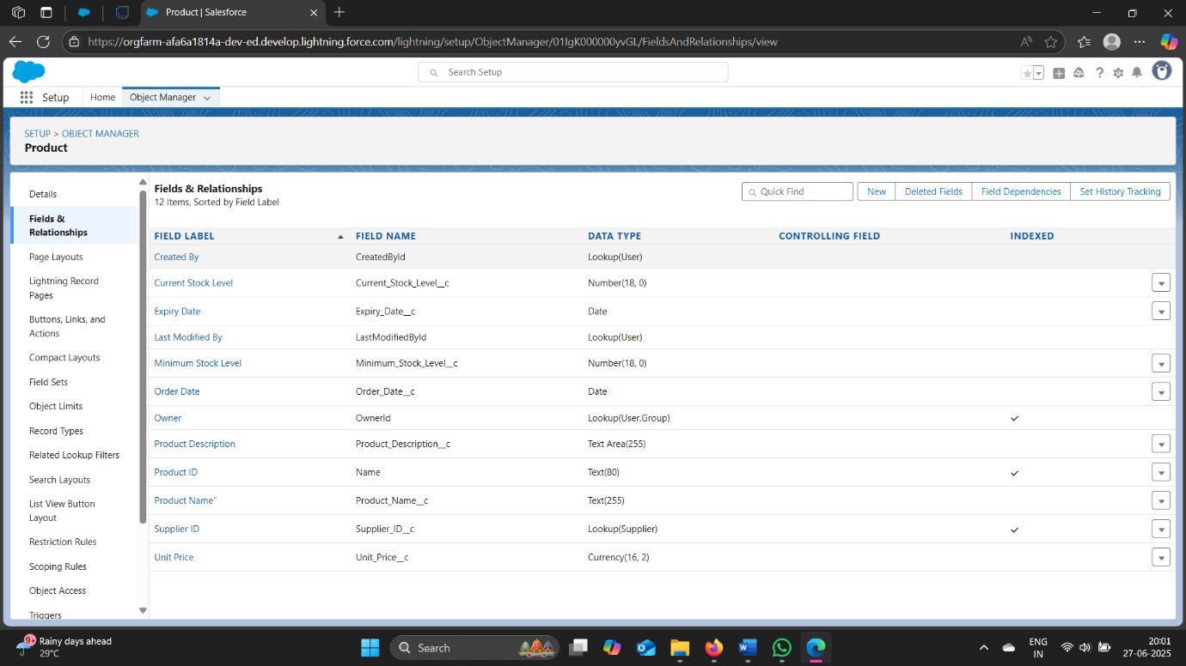

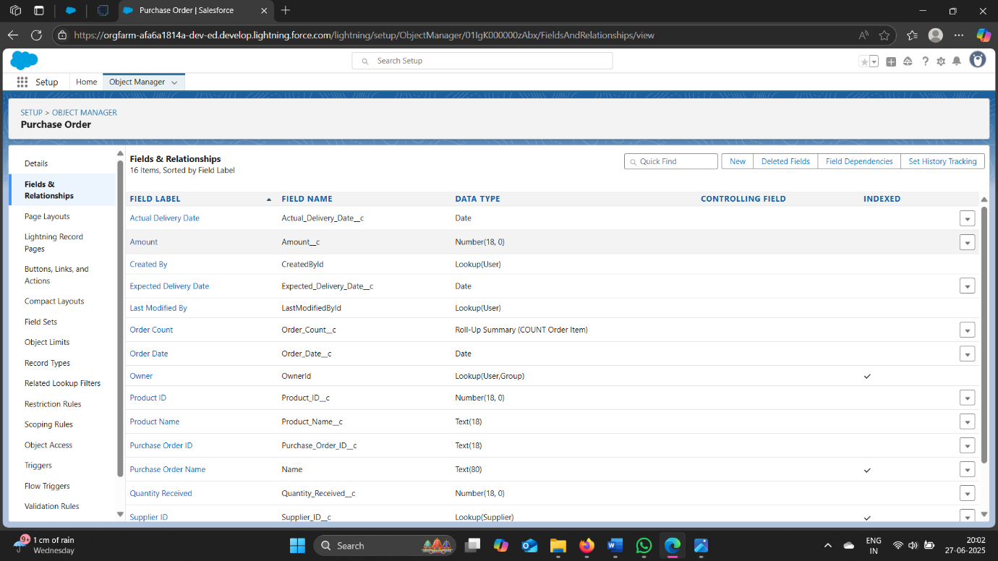

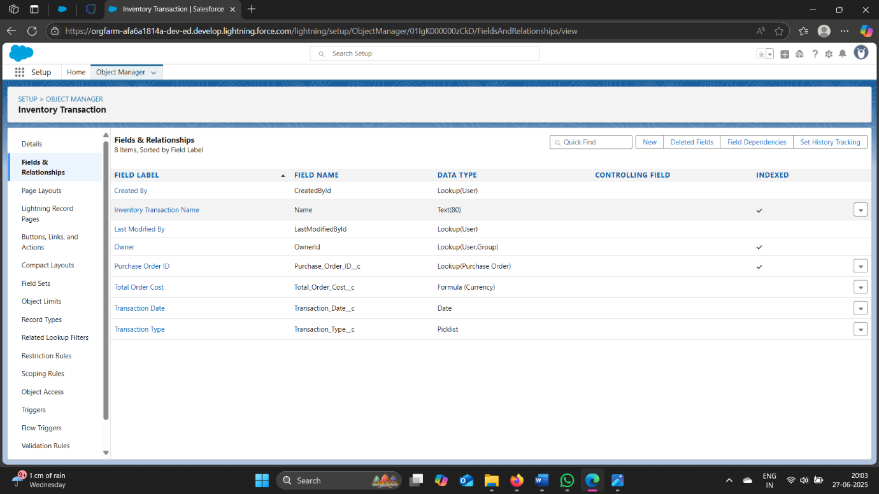

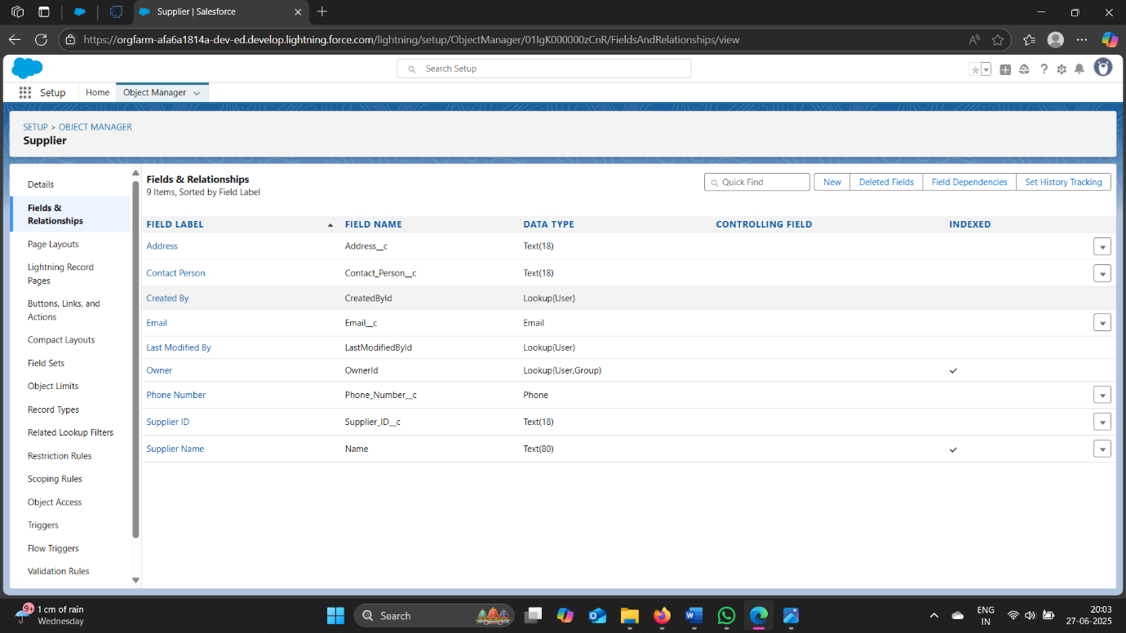

***MILESTONE 6: Editing of Page Layouts***

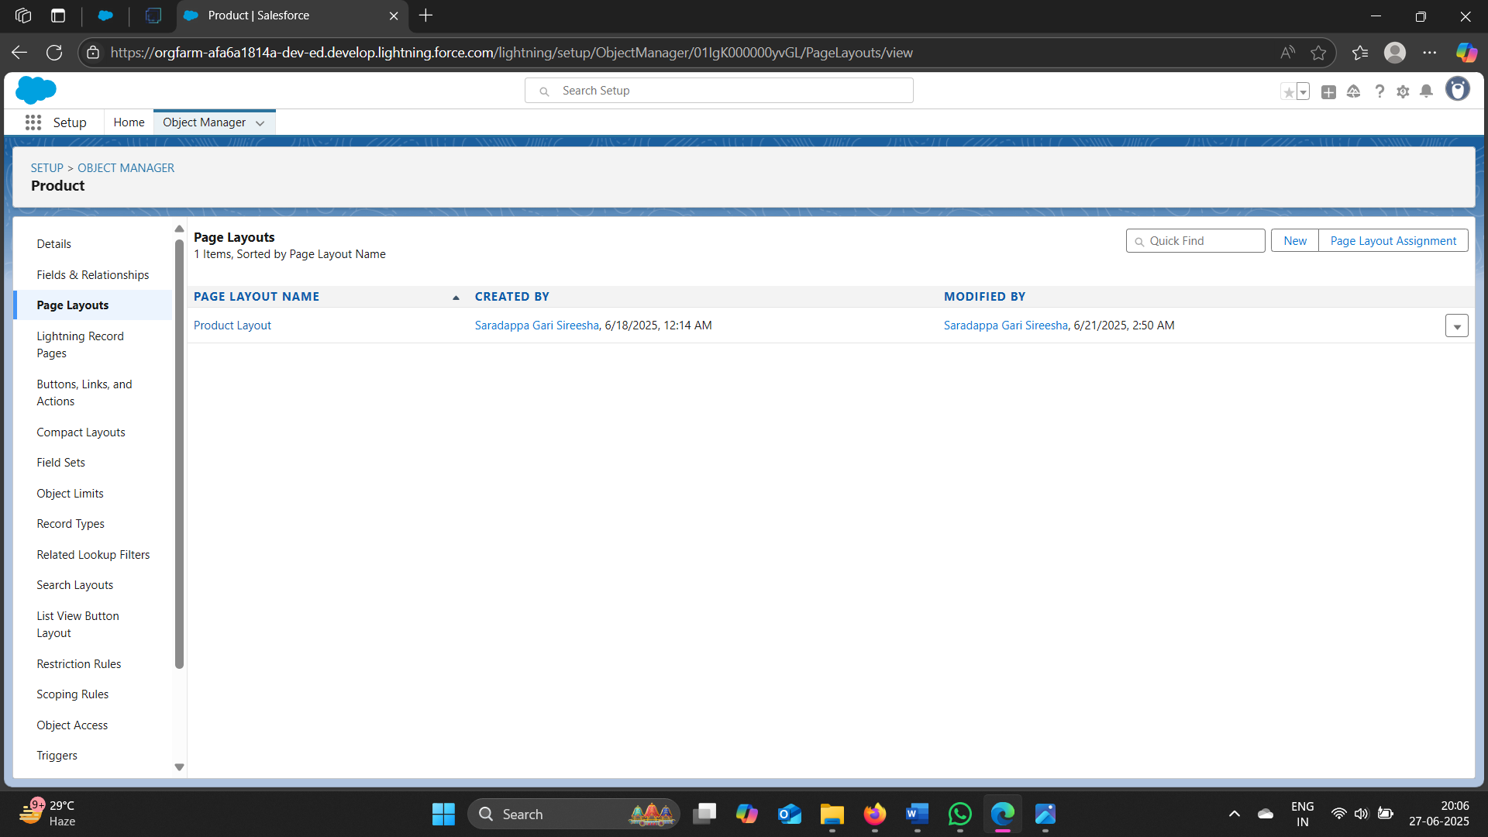

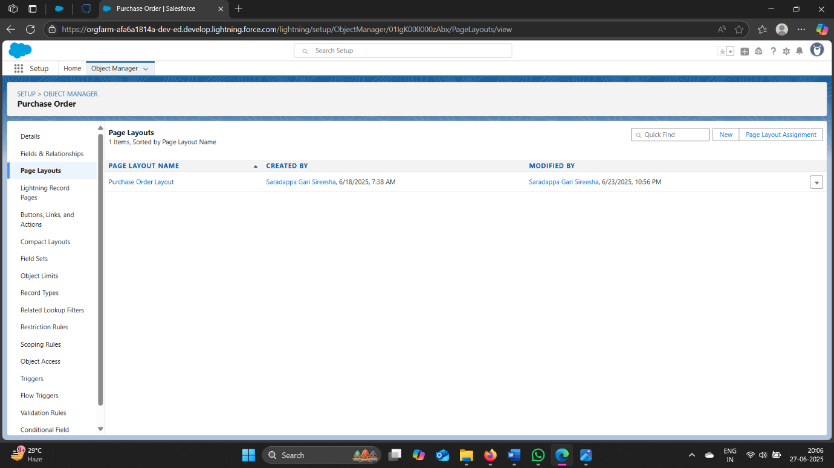

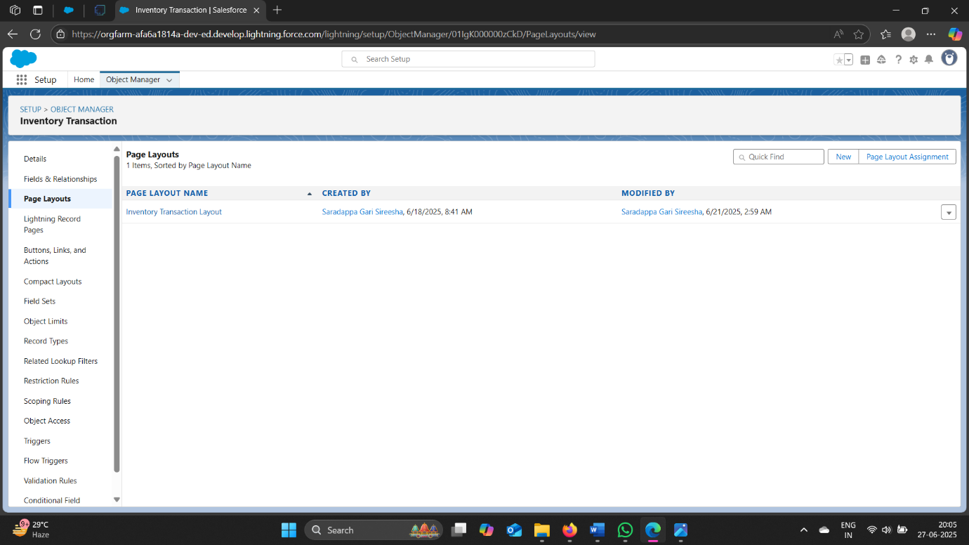

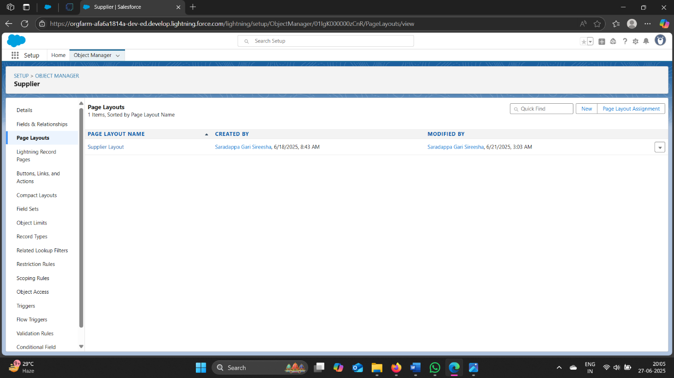

***MILESTONE 7: Compact Layouts***

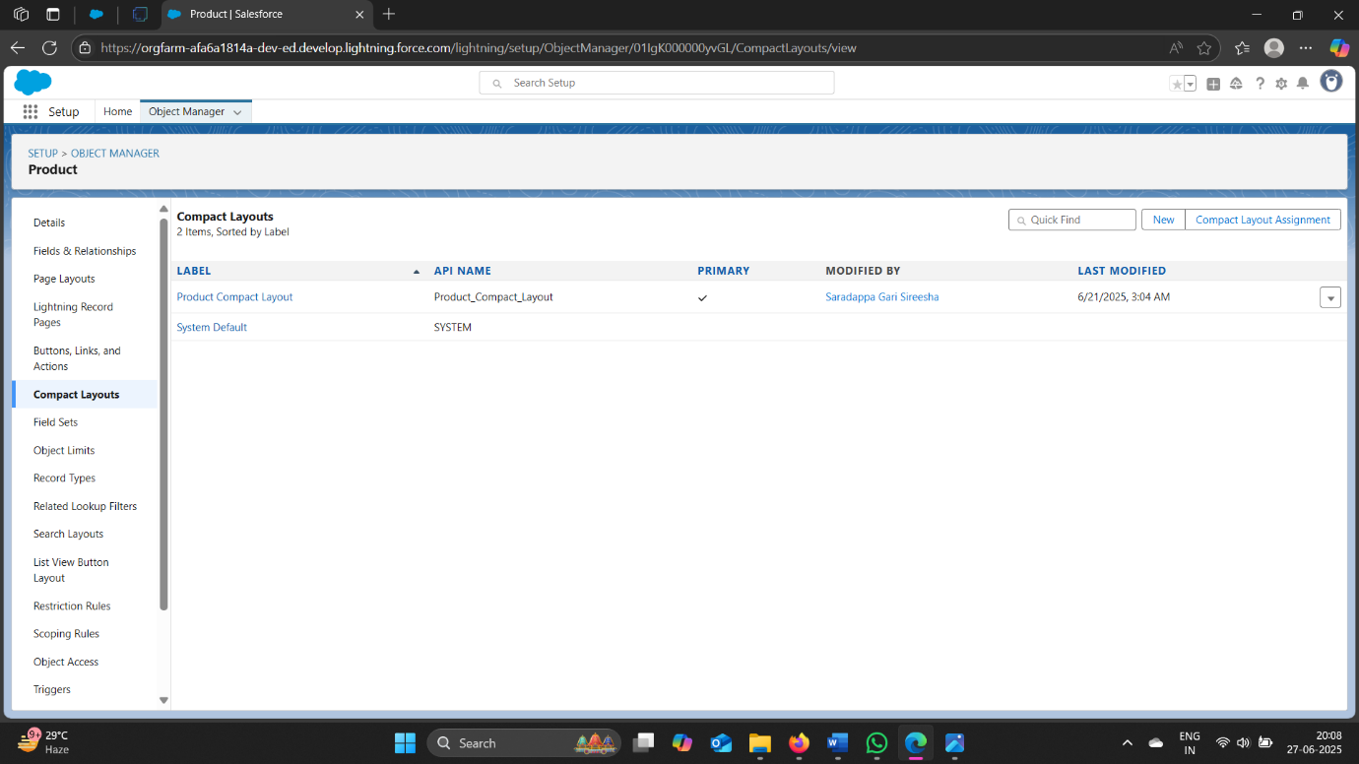

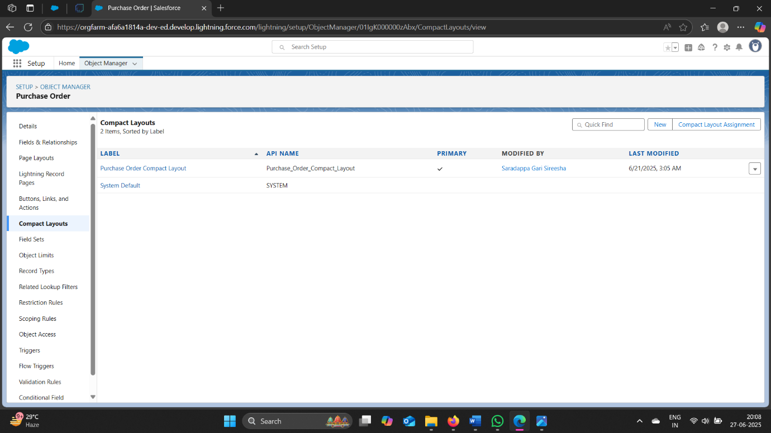

***MILESTONE 8: Validation Rules***

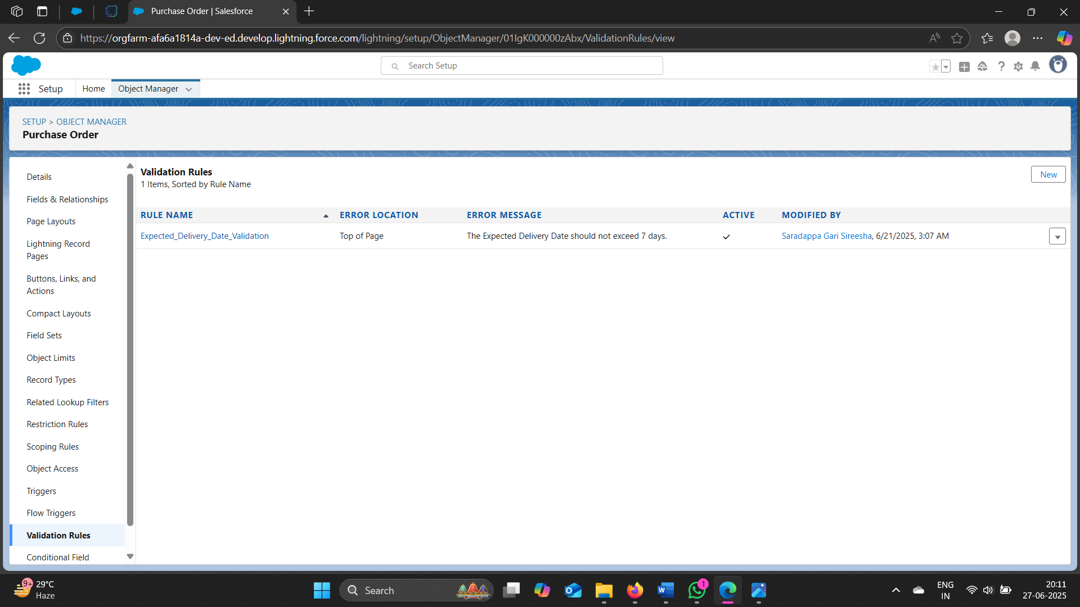

***MILESTONE 9: Profiles***

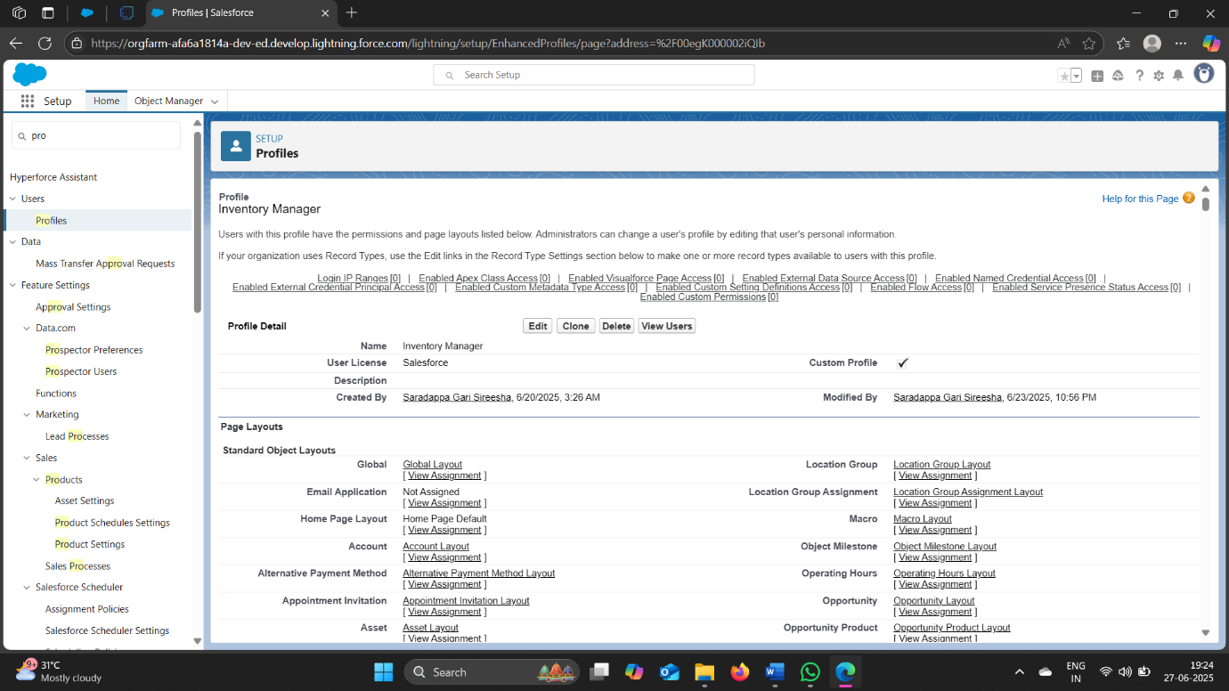

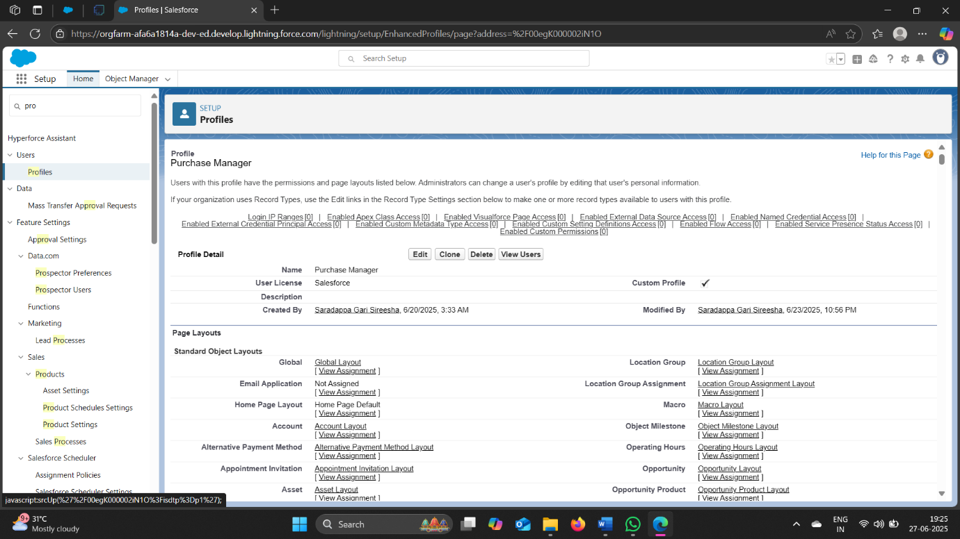

***MILESTONE 10: Roles***

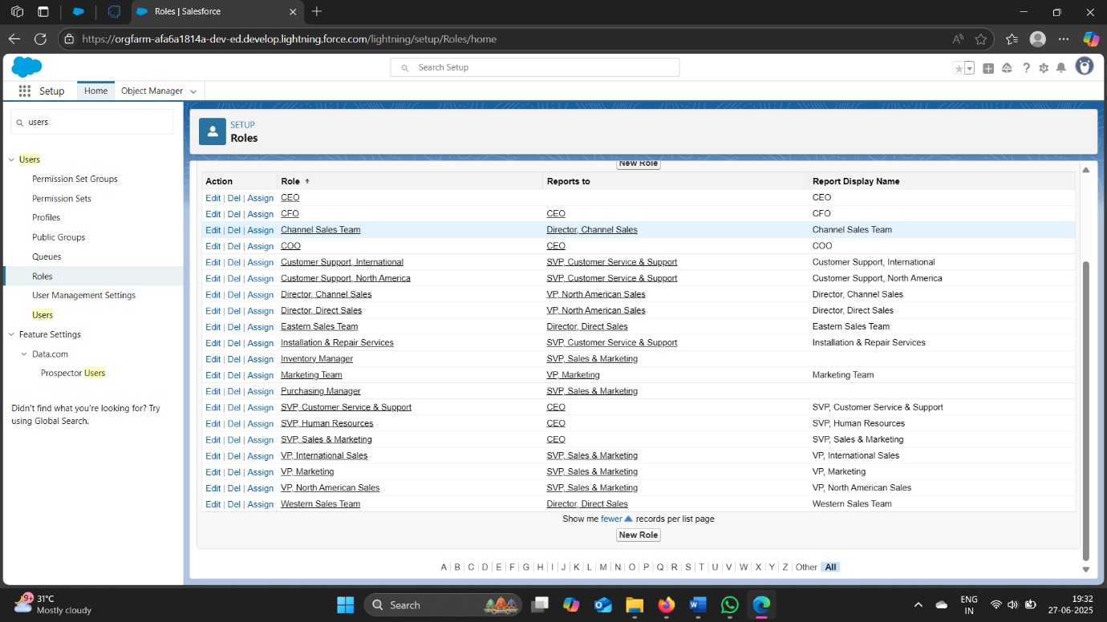

***MILESTONE 11: Users***

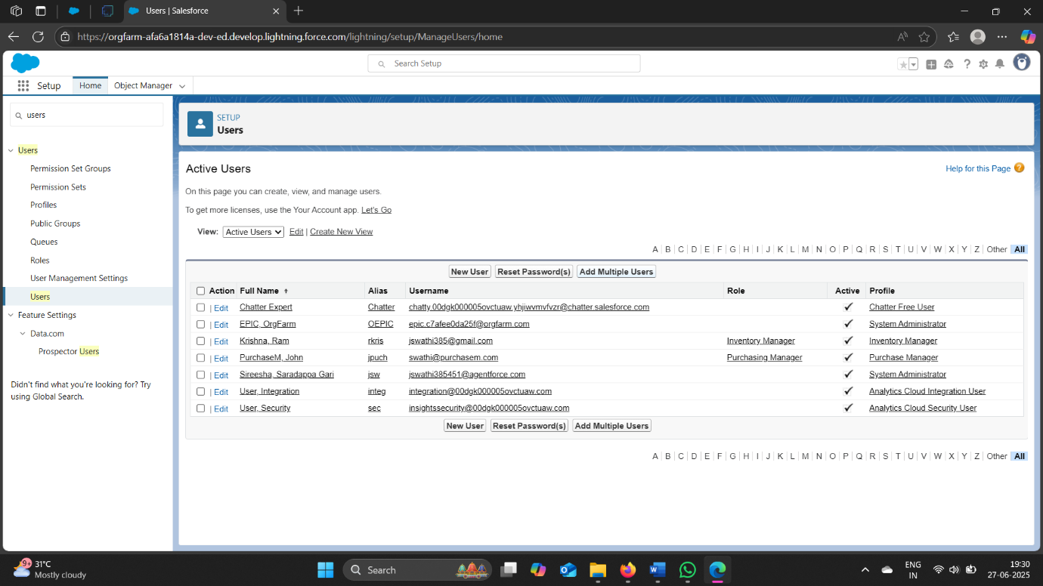

***MILESTONE 12: Permission Sets***

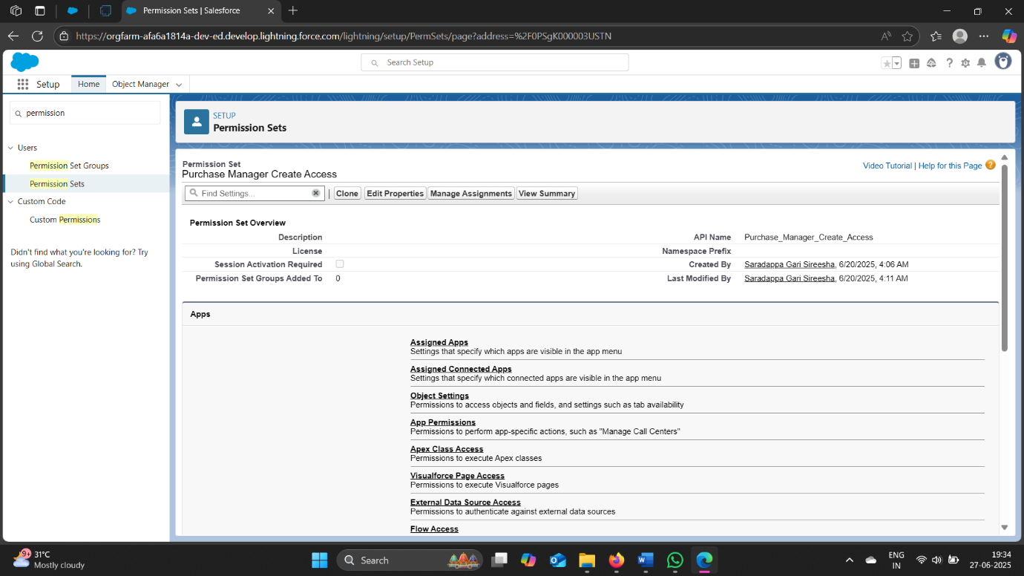

***MILESTONE 13: Flows*** 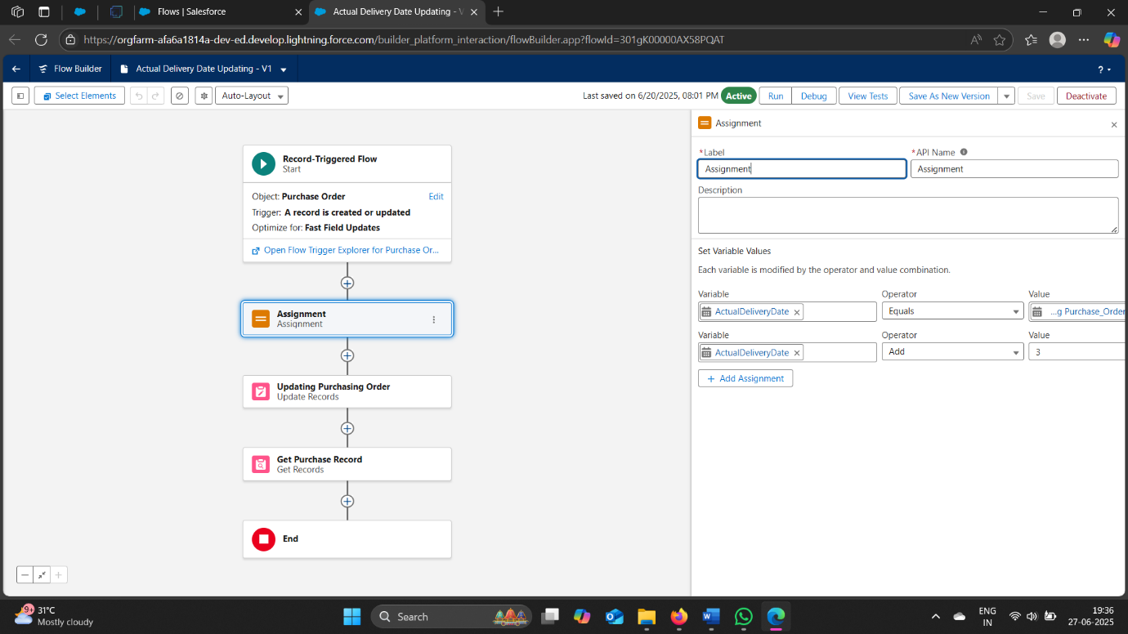

***MILESTONE 14: Triggers***

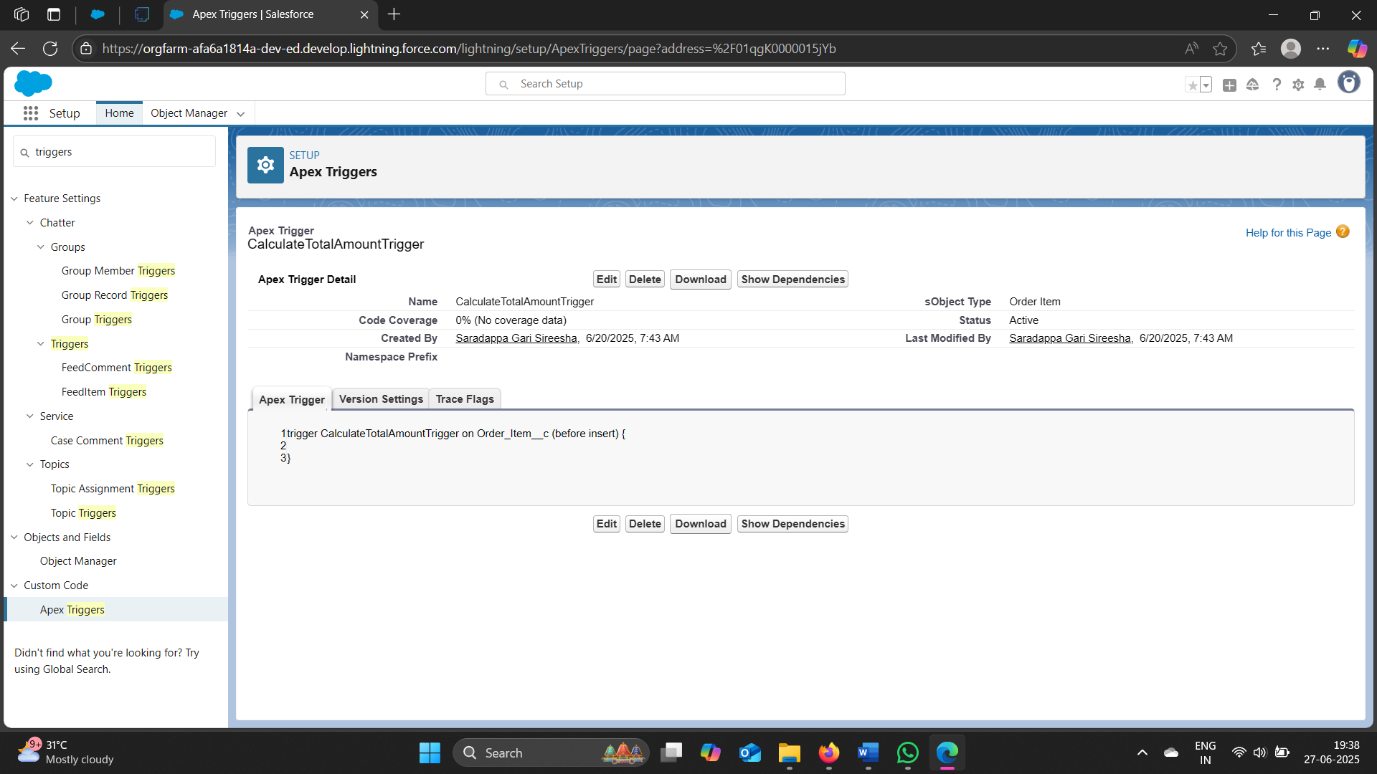

***MILESTONE 15: REPORTS***

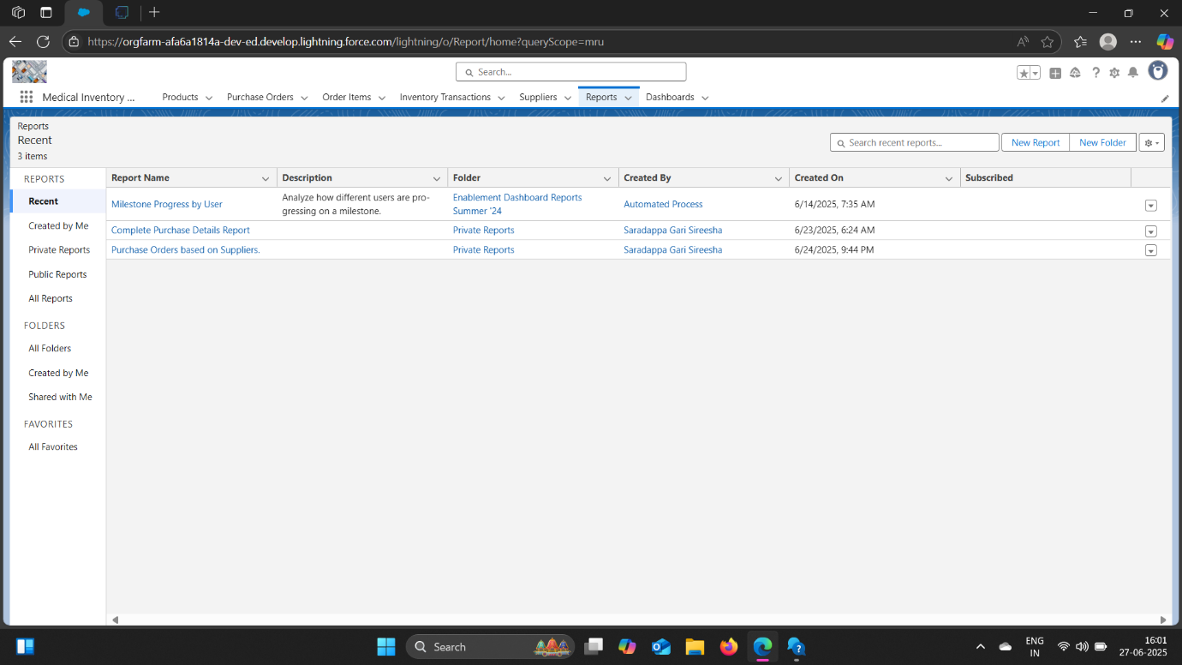

***MILESTONE 16: DASHBOARDS***

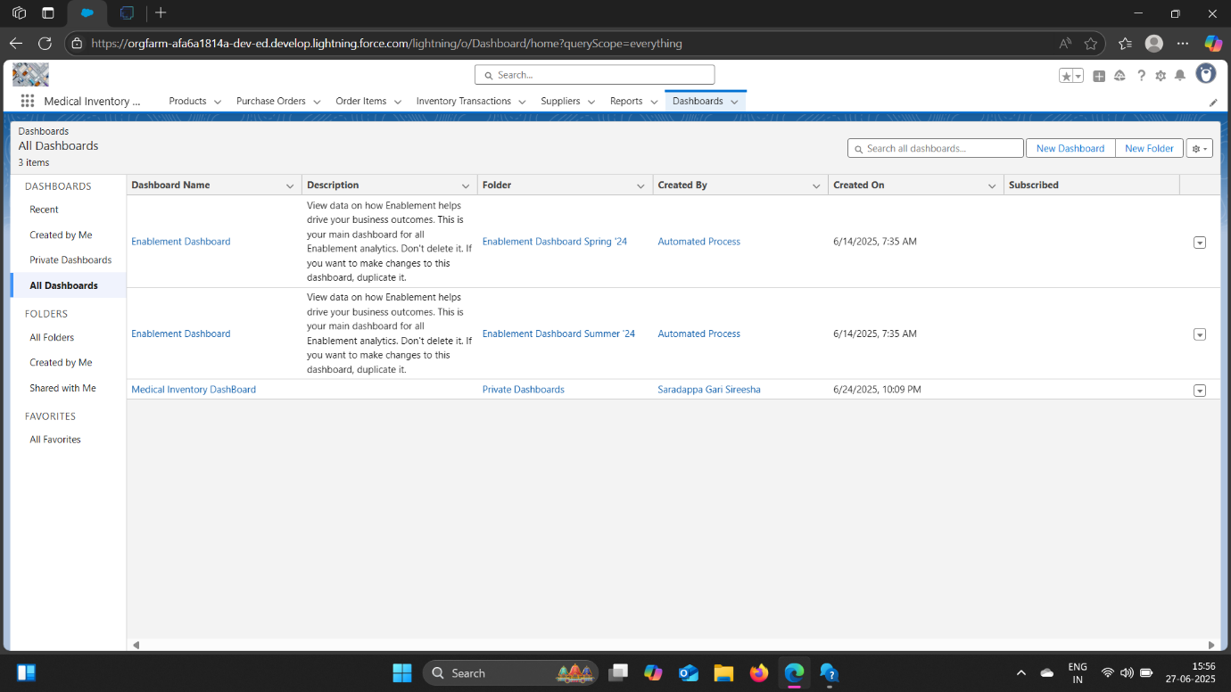

***8.ADVANTAGES***

***AND***

***DISADVANTAGES***

***ADVANTAGES***

* ***Improved Accuracy:*** Real-time tracking of inventory levels eliminates manual errors and ensures accurate stock counts.
* ***Optimized Stock Levels:*** Ensures essential medical supplies are available without overstocking, reducing waste and costs.
* ***Cost Efficiency:*** Reduces procurement costs through better planning and minimizes unnecessary expenses.
* ***Enhanced Patient Care***: Timely availability of critical medicines and equipment improves patient care and outcomes.
* ***Regulatory Compliance:*** Helps maintain adherence to healthcare standards and safety regulations.
* ***Supply Chain Visibility:*** Provides transparency across procurement, storage, and distribution.
* ***Automated Workflows:*** Streamlines inventory management processes, reducing manual efforts and increasing efficiency.
* ***Predictive Analytics:*** Enables demand forecasting and better planning, reducing stockouts and overstocking .
* ***Custom Objects:*** Create custom objects to track medical inventory, including products, warehouses, and inventory transactions.
* ***Lightning Components:*** Use Lightning Components to build custom user interfaces for inventory management.
* ***Apex Triggers:*** Use Apex triggers to automate inventory management workflows and enforce business rules.
* ***Salesforce Mobile App:*** Use the Salesforce Mobile App to access inventory management functionality on-the-go.

***DISADVANTAGES***

* ***Implementation Challenges:*** Integrating inventory management software with existing systems can be complex and time-consuming.
* ***Data Security Risks:*** Storing sensitive inventory data in the cloud may pose security risks if not properly protected.
* ***Dependence on Technology:*** Over-reliance on automated systems can lead to inefficiencies if technical issues arise.
* ***High Upfront Costs:*** Implementing a comprehensive inventory management system can require significant upfront investment.
* ***Training and Support:*** Requires training for staff to effectively use the system, which can be time-consuming and costly.

***Best Practices to Overcome Disadvantages:***

* + ***Assess Needs:*** Conduct thorough needs assessment before implementing inventory management software.
  + ***Choose the Right Solution:*** Select a solution that integrates with existing systems and meets specific needs.
  + ***Training and Support:*** Provide comprehensive training and ongoing support to staff.
  + ***Data Security Measures:*** Implement robust security measures to protect sensitive data.
  + ***Regular Audits:*** Conduct regular audits to ensure data accuracy and compliance.

***9.CONCLUSION***

The Medical Inventory Management project will provide a comprehensive solution for healthcare organizations to manage medical inventory, improving patient care and operational efficiency.

The Medical Inventory Management project in Salesforce is a comprehensive solution designed to streamline inventory management processes for healthcare organizations. By leveraging the Salesforce platform, this project aims to provide real-time tracking of medical supplies, equipment, and pharmaceuticals, ensuring that healthcare professionals have access to the resources they need to provide high-quality patient care.

***Challenges and Limitations:***

***1. Data Security and Compliance***: Ensuring that patient data and inventory information are secure and compliant with regulatory requirements.

***2. Integration with Existing Systems:*** Integrating with existing healthcare systems and ensuring seamless data exchange.

***3. User Adoption***: Ensuring that healthcare professionals adopt the new system and use it effectively.

By developing a Medical Inventory Management system in Salesforce, healthcare organizations can improve patient care, reduce costs, and increase efficiency, ultimately leading to better healthcare outcomes.

***10.FUTURE SCOPE***

***FUTURE ENHANCEMENTS***

Future enhancements may include integration with other healthcare systems, advanced analytics, and artificial intelligence-powered inventory management.

* ***Automated Inventory Tracking:*** Implement barcode scanning and RFID tracking to ensure accurate and real-time inventory updates
* ***Predictive Analytics***: Leverage machine learning algorithms to forecast demand and optimize inventory levels, reducing stockouts and overstocking
* ***Smart Reordering:*** Automate reordering processes based on predefined thresholds, lead times, and supplier constraints
* ***Inventory Visibility:*** Provide real-time visibility into inventory levels, locations, and movement across multiple warehouses and facilities
* ***Salesforce Health Cloud Integration:*** Integrate with Salesforce Health Cloud to leverage its capabilities in managing medical inventory, tracking product information, and streamlining sales processes
* ***Electronic Health Records (EHRs) Integration:*** Integrate with EHR systems to ensure seamless data exchange and accurate inventory management
* ***Supplier Integration:*** Integrate with supplier systems to enable real-time inventory updates, automated ordering, and streamlined communication

***11.APPENDIX***

***- Source Code***

***- Dataset Link***

***-Github & Project Demo Link***